polyCDNA

Assessment Statements
- Outline the main steps and locations of gene expression
- Explain how the DNA double helix is formed using complementary base pairing and hydrogen bonds
- Draw and label a simple diagram of the molecular structure of DNA (four bases, phosphate, sugar)
- Explain the technical terms DNA, chromosome, genome, chromatid, gene and allele

Very short overview of Gene Expression
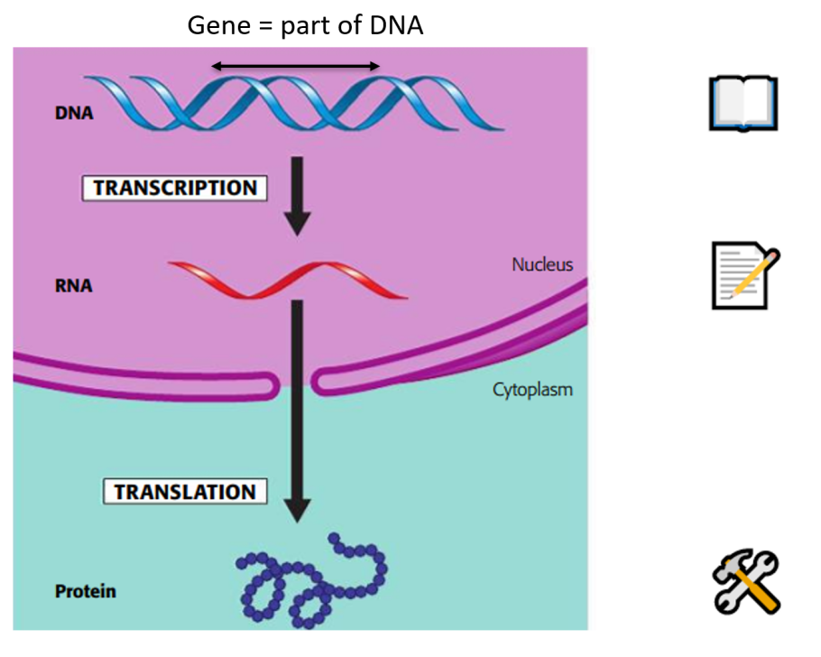

A more detailed overview
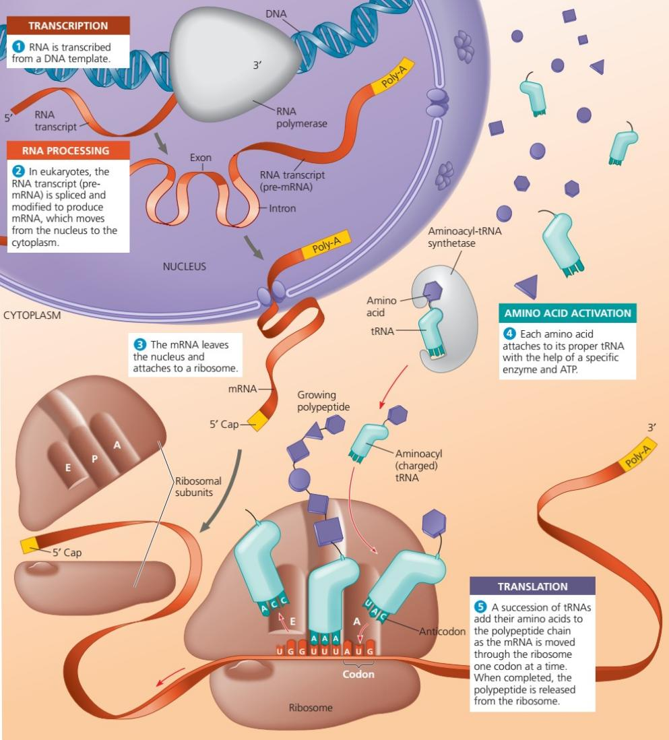

DNA structure
DNA is located in the nucleus (for eukaryotes, in bacteria DNA is located at a certain place, but not in an organelle). DNA contains the entire information of an organism: How it is built up, how it works and to a certain extent also how it behaves. In each cell of an organism the full DNA is stored although only a minor part is used. As an example, heart cells also contain information about liver function and which eye colour you have.

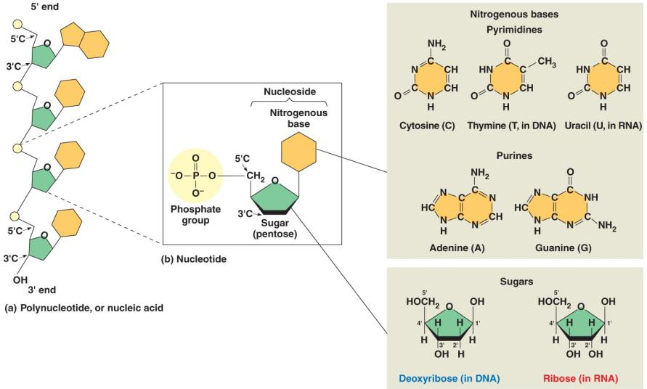

DNA contains a backbone which serves for stability and on which the bases are bound. The backbone consists of sugar (deoxyribose) and phosphates. The information is stored in the bases, more precisely in the order of the bases. There are four types of bases (adenine, guanine, cytosine, thymine). Their 1-letter-abbreviations A, G, C, T are comparable to our letters. The order of the bases is read by the cell similar as we read the words in a book. In this comparison a gene would be a word. Humans have around 20’000 genes and a gene can contain many thousands bases. In total, there are 3 billion bases in our DNA.
Adenine, cytosine, guanine, thymine and uracil are bases. A base with a sugar is called nucleoside. A base with a sugar and a phosphate is called nucleotide.

Base pairing
DNA consists of two nucleotide strings linked together via hydrogen bonds. There are certain limitations: Adenine is always linked with thymine and cytosine with guanine. Therefore, we only have to know the base sequence of one side to know how the other looks like:
You read ATTGC on one side, what is the sequence of the other string: TAACG

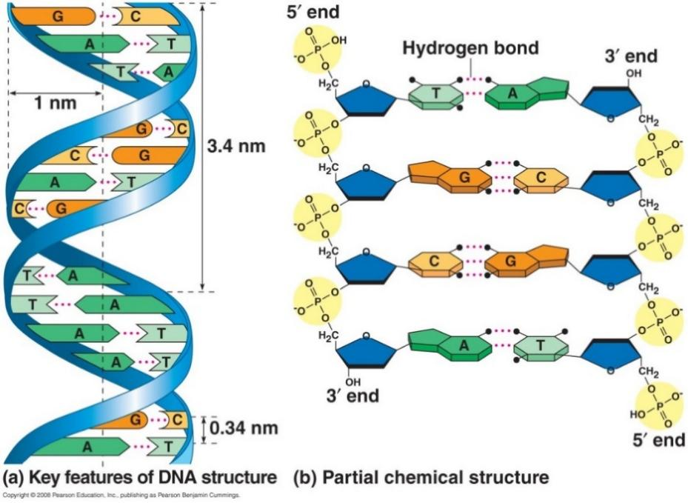
Hydrogen bonds are weak bonds and can be unzipped without much energy investment. However, thousands of them hold together the DNA quite firmly.

Technical terms in genetics
Use the diagram below (or draw your own diagram) to label/explain the following technical terms:
DNA, chromosome, genome, chromatid, gene, allele
Allele- Describes the same thing with different information

Gene - Describes the same thing
DNA / Cromatid
DNA
Genome

Used Tools and References
- Reece, J. B. et al. (2008). Campbell Biology. (8th edition). Pearson Education.
- Reece, J. B. et al. (2018). Campbell Biology. (11th edition). Pearson Education.
- Simon, E. J., Reece, J. B., Dickey, J. L. (2013). Essential Biology with Physiology. (4th edition). Pearson Education.
- Sadava, D. et al. (2011). Life - The Science of Biology. (9th edition). Sinauer Associates.

CC BY 4.0 DEED for contents created by Daniel Margadant
For other sources (e.g., figures) please consider © of corresponding reference

